An Analysis of the Anime Industry

Abstract— In this study, we will conduct a brief analysis on the trends Anime in outside of Japan. This will be done by comparing the performance of anime from 1990-2018 from two major rating websites, MyAnimeList and Anime-Planet. The analysis of the trends in the industry will be carried out utilizing visual analytics and Regression.

Introduction
Prior to the early 2000s, the word “Anime” was predominantly popular in Japanese youth culture and had not extensively penetrated western markets. (Williams, 2019) However, in the prior two decades, it is no doubt that anime and Japanese pop culture has influenced western society in many ways. There has been a domestication of anime in western society and it is evident in the increased viewership of anime in popular streaming services such as Netflix and Crunchyroll. (Yeung, 2020) Furthermore, said services have been pooling large investments into this ever-popular genre of media.
In 2019, the anime industry is a record high of $24.08 billion dollars in revenue, with an overseas contribution of 51%. (Wit, 2020) It could be the big shift in entertainment, catering to people of all ages, from children to adults. The analysis conducted in this report focuses on the growth of anime consumption, outside of Japan.

ANALYSIS DOMAIN, QUESTIONS AND PLAN

Data and Domain
There are two major websites that house western reviews of anime, one of which is MyAnimeList (MAL) and the second is Anime-Planet (AP). Data has been obtained in two ways for the purpose of this study. The first is obtained through a dataset on Kaggle, containing the reviews from MyAnimeList, this contains the genres, number of episodes, air date, duration, number of votes etc. Similarly, the number of votes, rating and other details have been scraped from Anime-Planet. Since anime are produced in Japanese, it is difficult to use names to join the two datasets. To solve this issue, using the Minami dataset (manami-project, 2020), a project dedicated to linking anime titles across different websites, we will be scraping Anime-Planet using this relation.
There are two target variables in this study, these are the scores given to the show/ movie on each of the two websites, with the scores on MAL ranging from 0-10 and AP ranging from 0-5. These scores can be translated into the performance of the anime in terms of customer satisfaction.

Research Questions
MAL is the most popular resource for western anime viewers to post their reviews, with there being over 120 million users a month frequenting the site. It is the most extensive database of information related to the industry, including categorisation of different shows. (Orsini, 2018) (Lodron Zuin, Gonc ̧alves Magalh ̃aes, & Corrˆea Loures, 2016)
The aim of the analysis is to identify how the trends have changed in anime, over the last 20 years and identify different genres and target audiences which are doing particularly well. The questions below will be the main scope of the analysis:
- What is the trend in anime consumption, is there any change in the number of of users watching anime?
- What factors affect anime rating on the two websites, are there any seasonal variations in data?
- Do the users on each of the websites hold similar preferences or are they catered to different markets?
- How does length of the media (in episodes and run time) affect rating? Do certain genres do better than others?
- How do different target audiences, Shoujo, Shounen, Seinen and Josei (teen male, young adult male, teen female and young adult female respectively) react to anime?

Analytical Approach

Using Minami, web-scrape Anime-Planet and join on AnimeId
- Clean data and impute missing values.
- Data transformations and feature engineering
- Exploratory analysis and investigate relationships.
- Model score prediction and difference in scores.

Findings and discussion

Overview of the Industry
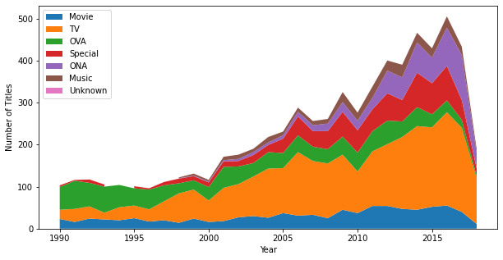
Figure 1- Titles of each type of Media from 1990 -2018
To understand how the industry has grown, we need to understand how the consumption of anime media has changed over the last 30 years. In figure 1, it clear that the total number of titles being produced every year has increased significantly. Prior to the 2000s, there was a lot more consumption in anime primarily through OVA. These are limited run-time media which summarise the plot of manga and novels, unlike TV shows which are longer running. There has been a significant growth in TV and Specials consumption (720% and 1750% since 1990), especially after the 2000s and again a resurgence after 2010. The number of ONA titles has also grown significantly, especially after 2010 (165.2%). ONA is generally media of other east Asian countries including Korean and Chinese media. The popularity of anime earlier on, may have induced an increase in ONA production.
The growth in film production seems to be quite slow, with a slow increase yearly- this may be due to the resources required to creating a film being much greater with respect to advertising, pre- and post-production expenses, compared to TV series.
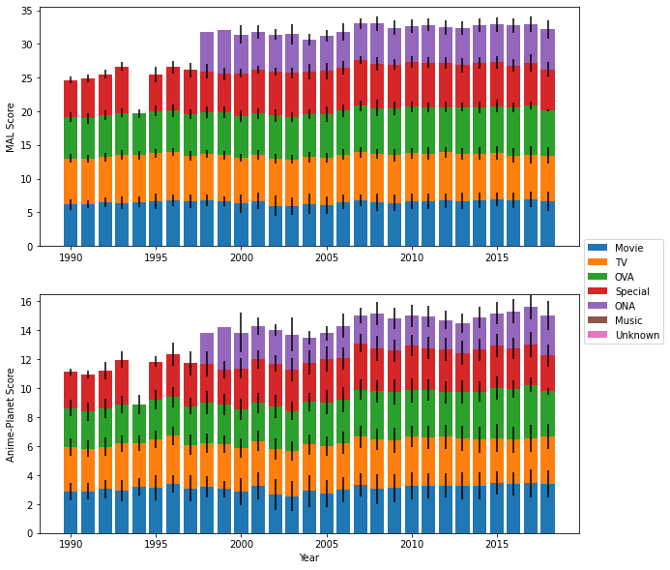
Figure 2- Change in Score from 1990-2020
The Scores have not drastically changed over the years, as shown in figure 2. This is surprising, as the number of titles has been consistently increasing for most media. With MAL, the standard deviation in all media has increased, with the greatest being in Television and Movie titles (84.4% and 82.7% respectively). This shows that the disparity in scores of bad titles and good titles has increased and the overall quality of the media has not changed. The scores for Anime-Planet have consistently high variance, with scores between titles varying a lot.

Audience Analysis

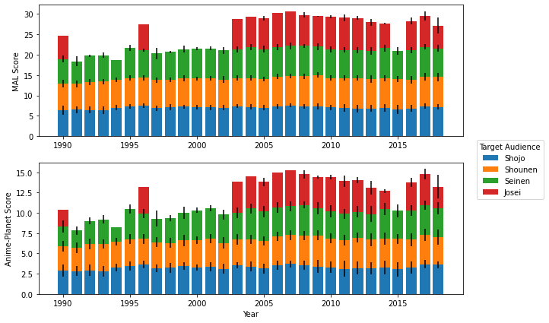
Figure 3- Different Target Audiences and their Average Ratings

Figure 3 shows how different target audiences react to anime shows. Shounen scores have steadily increased on both sites, from an average by 6.89% and 12.53% in MAL and AP respectively from the 90s to the 2010s. This is while, the standard deviation between the scores of titles being constant.
The other target audiences do not seem

Figure 4- Comparison of ratings between the two Websites

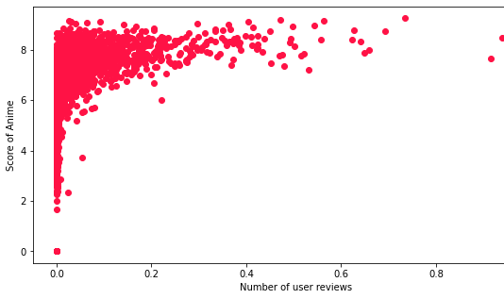Figure 5- Score of Anime vs number of User Reviews
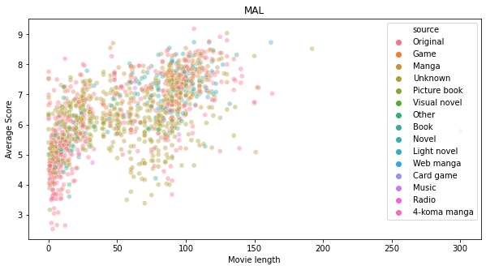
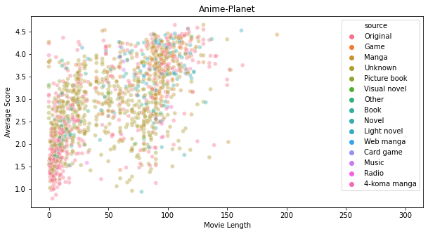
Figure 6- Movie Length vs Average Score

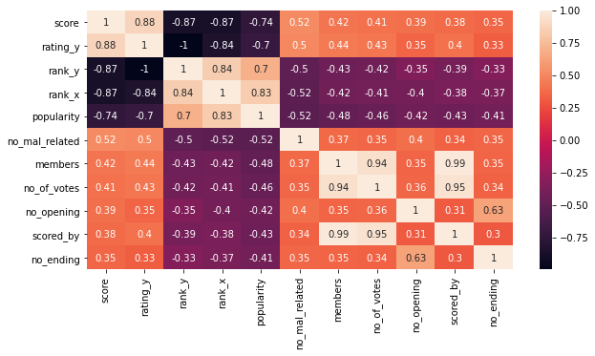
Figure 7- Correlation Matrix

Bibliography
Lodron Zuin, G., Gonc ̧alves Magalh ̃aes, L., & Corrˆea Loures, T. (2016). MAL-FITT:MyAnimeList Forum Interpreter Through Text. BRACIS 2016- Brazilian Confrence on Intelligent Systems (pp. 205-206). Rio De Janeiro: XIII National Meeting on Artificial and Computational Intelligence - ENIAC'2016.
Orsini, L. (2018, May 30). MyAnimeList Passes Third Day Of Unexpected Downtime. Retrieved from Forbes: https://www.forbes.com/sites/laurenorsini/2018/05/30/myanimelist-passes-third-day-of-unexpected-downtime/?sh=9396b197e9e2#4de588827e9e
Williams, M. (2019, July 29). variety.com. Retrieved from Variety est 1905.: https://variety.com/2019/tv/news/anime-streaming-netflix-1203278207/
Wit, A. D. (2020, November 27). Anime Industry Grew To Record $24.1 Billion In 2019, Says Trade Body. Retrieved from cartoonbrew: https://www.cartoonbrew.com/business/anime-industry-grew-to-record-24-1-billion-in-2019-says-trade-body-199002.html
Yeung, J. (2020, October 21). Netflix Announces Five New Anime Originals for 2021. Retrieved from HypeBeeast: https://hypebeast.com/2020/10/netflix-anime-festival-2020-announcements

